Reliability and Safety Analysis

Year: 2021 Semester: Fall Team: 8

Project: Sink or be Sunk

Creation Date: October 2, 2021 Last Modified: October 5, 2021

Author: Garrett Brillhart Email: gbrillha@purdue.edu

Assignment Evaluation:

|  |  |  |  |  |
| --- | --- | --- | --- | --- |
| **Item** | **Score (0-5)** | **Weight** | **Points** | **Notes** |
| **Assignment-Specific Items** | | | | |
| **Reliability Analysis** | 5 | x2 |  |  |
| **MTTF Tables** | 5 | x3 |  |  |
| **FMECA Analysis** | 5 | x2 |  |  |
| **Schematic of Functional Blocks (Appendix A)** | 5 | x2 |  |  |
| **FMECA Worksheet (Appendix B)** | 5 | x3 |  |  |
| **Writing-Specific Items** | | | | |
| **Spelling and Grammar** | 5 | x2 |  |  |
| **Formatting and Citations** | 5 | x1 |  |  |
| **Figures and Graphs** | 5 | x2 |  |  |
| **Technical Writing Style** | 5 | x3 |  |  |
| **Total Score** | 100 | | |  |

5: Excellent 4: Good 3: Acceptable 2: Poor 1: Very Poor 0: Not attempted

Comments:

*Excellent analysis!*

1. Reliability Analysis

*ESP32-WROOM32*

The ESP32-WROOM32 is used to control the entire Sink or be Sunk board game chosen for reliability analysis because of its complexity and importance to the project. The failure per 10^6 hours (𝝀𝑷) and mean time to failure (MTTF) was calculated based on the formulas outlined in MIL-HDBK-217F. The CMOS Gate/Logic Arrays and Microprocessor model was used for this microcontroller, 𝝀𝑷 = (C1 · πt + C2· πe) · πQ · πL. The MTTF and 𝝀𝑷 is in an acceptable range. A failure in this microcontroller system would degrade gameplay functionality and could shut the game down entire, but no harm to the user is at risk.

Table 1: Failure Analysis of ESP32

|  |  |  |  |
| --- | --- | --- | --- |
| Parameter Name | Description | Value | Comments |
| C1 | Die Complexity | 0.56 | 32-Bit MOS |
| πT | Temperature Coefficient | 0.98 | Maximum Operating Temp at 85° C |
| C2 | Pin/Package Constant | 0.017 | Non-Hermetic 36 Pin |
| πE | Environmental Factor | 0.5 | GB |
| πQ | Quality Factor | 10 | Commercial Component |
| πL | Learning Factor | 1 | ESP32 has been in production since 2016 |
| Entire Design |  |  |  |
| 𝝀𝑷 |  | 5.573 |  |
| MTTF |  | 0.179 |  |

The MTTF and failure rate is lower than desired in a perfect world, with 5.573 failures per million hours. However, the temperature coefficient is conservatively based on the microcontroller operating at 85° C which will never get that hot with the workload the ESP will be doing in our project. If it were put to the average temperature of 45° C which the ESP will almost certainly never pass, the failure rate would be 1.429 and MTTF would be 0.6998, which is more realistic and satisfactory in reliability. Also, the quality factor of 10 is also controversial, and with modern practices would bring down the failure rate to be much lower. In summary, our conservative estimate of a MTTF of 0.179 is not bad, and realistically will have a much higher MTTF with implementation.

*Worldsemi WS281C*

The Worldsemi WS281C are LEDs responsible for conveying information to the user about hits and misses on the board. It was chosen due to the sheer number per board (128), amount of power drawn, and importance to the project. The failure per 10^6 hours (𝝀𝑷) and mean time to failure (MTTF) was calculated based on the formulas outlined in MIL-HDBK-217F. The optoelectronics, detectors, isolators, and emitters’ formula was chosen for this LED, 𝝀𝑷 = 𝝀b · πT · πQ · πE. The MTTF and 𝝀𝑷 is in the expected range. A failure in an LED could disrupt the daisy chain of LEDs and degrade the user experience and visual feedback but with no risk of harm to the user.

Table 2: Failure Analysis of WS281C

|  |  |  |  |
| --- | --- | --- | --- |
| Parameter Name | Description | Value | Comments |
| 𝝀b | Optoelectronic type | 0.00023 | LED |
| πT | Temperature Coefficient | 3.4 | No max operating temperature given, assuming max of 70° C |
| πQ | Quality Factor | 8.0 | Plastic |
| πE | Environmental Factor | 1.0 | GB |
| Entire Design |  |  |  |
| 𝝀𝑷 |  | 0.006256 |  |
| MTTF |  | 159.85 |  |

The MTTF and failure rate is extremely low, with 0.006256 failures per million hours. No mitigation towards reducing the failure rate is needed. It should be considered however, that the LEDs pass bits as well so the LED could be considered an IC, but for this case it is assumed that it is a plain LED. If the LED was analyzed as a IC the failure rate would likely be higher.

*AC/DC Converter PSC15A-050*

The PSC1A-050 is an AC/DC converter that plugs into the wall and supplies power to the entire board. It was chosen due to its importance as the primary power source to the board and the amount of power/current it will handle. The failure per 10^6 hours (𝝀𝑷) and mean time to failure (MTTF) was calculated based on the formulas outlined in MIL-HDBK-217F. The model of CMOS Switch-Mode Regulator formula was chosen for this device, 𝝀𝑷 = (C1 · πt + C2· πe) · πQ · πL. A failure in the wall plug would require replacement but the user experience would only degrade to not being able to use the rumble motor due to the use of a backup battery. No user risk exists for the wallplug as long as the user manual is followed and safe protocls are followed when plugging the device in.

Table 4: Failure Analysis of AC/DC Converter

|  |  |  |  |
| --- | --- | --- | --- |
| Parameter Name | Description | Value | Comments |
| C1 | Die Complexity | 0.01 | 1-1,000 bipolar transistors |
| πT | Temperature Coefficient | 0.34 | CMOS Operating Temp at 40° C |
| C2 | Pin/Package Constant | 0.0012 | Non-Hermetic 3 Pin SMT |
| πE | Environmental Factor | 0.5 | GB |
| πQ | Quality Factor | 10 | Commerical Component |
| πL | Learning Factor | 1 | The IC inside is >2 years in production |
| Entire Design |  |  |  |
| 𝝀𝑷 |  | 0.04 |  |
| MTTF |  | 25 |  |

The MTTF and failure rate is low, with 0.04 failures per million hours. The only mitigation that might be necessary would be to make a cooling application, as the amount of power and current the plug will handle from the wall is high. It should also be considered that no perfect formula on the MIL spec matches an AC/DC converter wall plug, so just considering the IC on the regulator must be assumed. Other factors from the plug may raise the failure rate, but lack of information prevents a more detailed analysis.

1. Failure Mode, Effects, and Criticality Analysis (FMECA)

Levels of criticality are necessary to specify and differentiate which failure modes must have a lower failure rate and which are allowed to be more failure prone.

A ‘Low’ criticality specifies that the failure is not harmful to the user or destructive to the other components on the board. The board may still be unusable until the part is replaced and is intended to have a failure rate of 10^-6 or less.

A ‘Medium’ criticality is defined as a failure that does not harm the user but has a potential to damage or destroy components on the board. A failure on the DC/DC switching regulator could be medium criticality as a failure there and in the AC/DC converter could have the potential to blast AC throughout the system. ‘Medium’ is aimed to have a failure rate of 10^-7 or less.

A ‘High’ criticality is for failures that present potential harm to the user, such as fires or emitting harmful gases or material. ‘High’ failure rate is aimed to have a failure rate of 10^-9 or less.

3.0 Sources Cited:

[1] “Military Handbook,”1 1990. [Online]. Available: http://snebulos.mit.edu/projects/reference/MIL-STD/MIL-HDBK-217F-Notice2.pdf [Accessed 11 5 2014].

[2] Phihong, “15 Watt Fixed Wall Plug Series Level VI Requirements” 9 2021. [Online]. Available: https://www.phihong.com/admin/uploads/PSX15A.pdf [Accessed 11 5 2021].

[3] Espressif, “ESP32 Series Datasheet” 2021. [Online]. Available: https://www.espressif.com/sites/default/files/documentation/esp32_datasheet_en.pdf [Accessed 11 5 2021].

[4] LCSC, “WS2812C” 2021. [Online]. Available: https://datasheet.lcsc.com/lcsc/1810231210_Worldsemi-WS2812C_C114587.pdf [Accessed 11 5 2021].

Appendix A: Schematic Functional Blocks

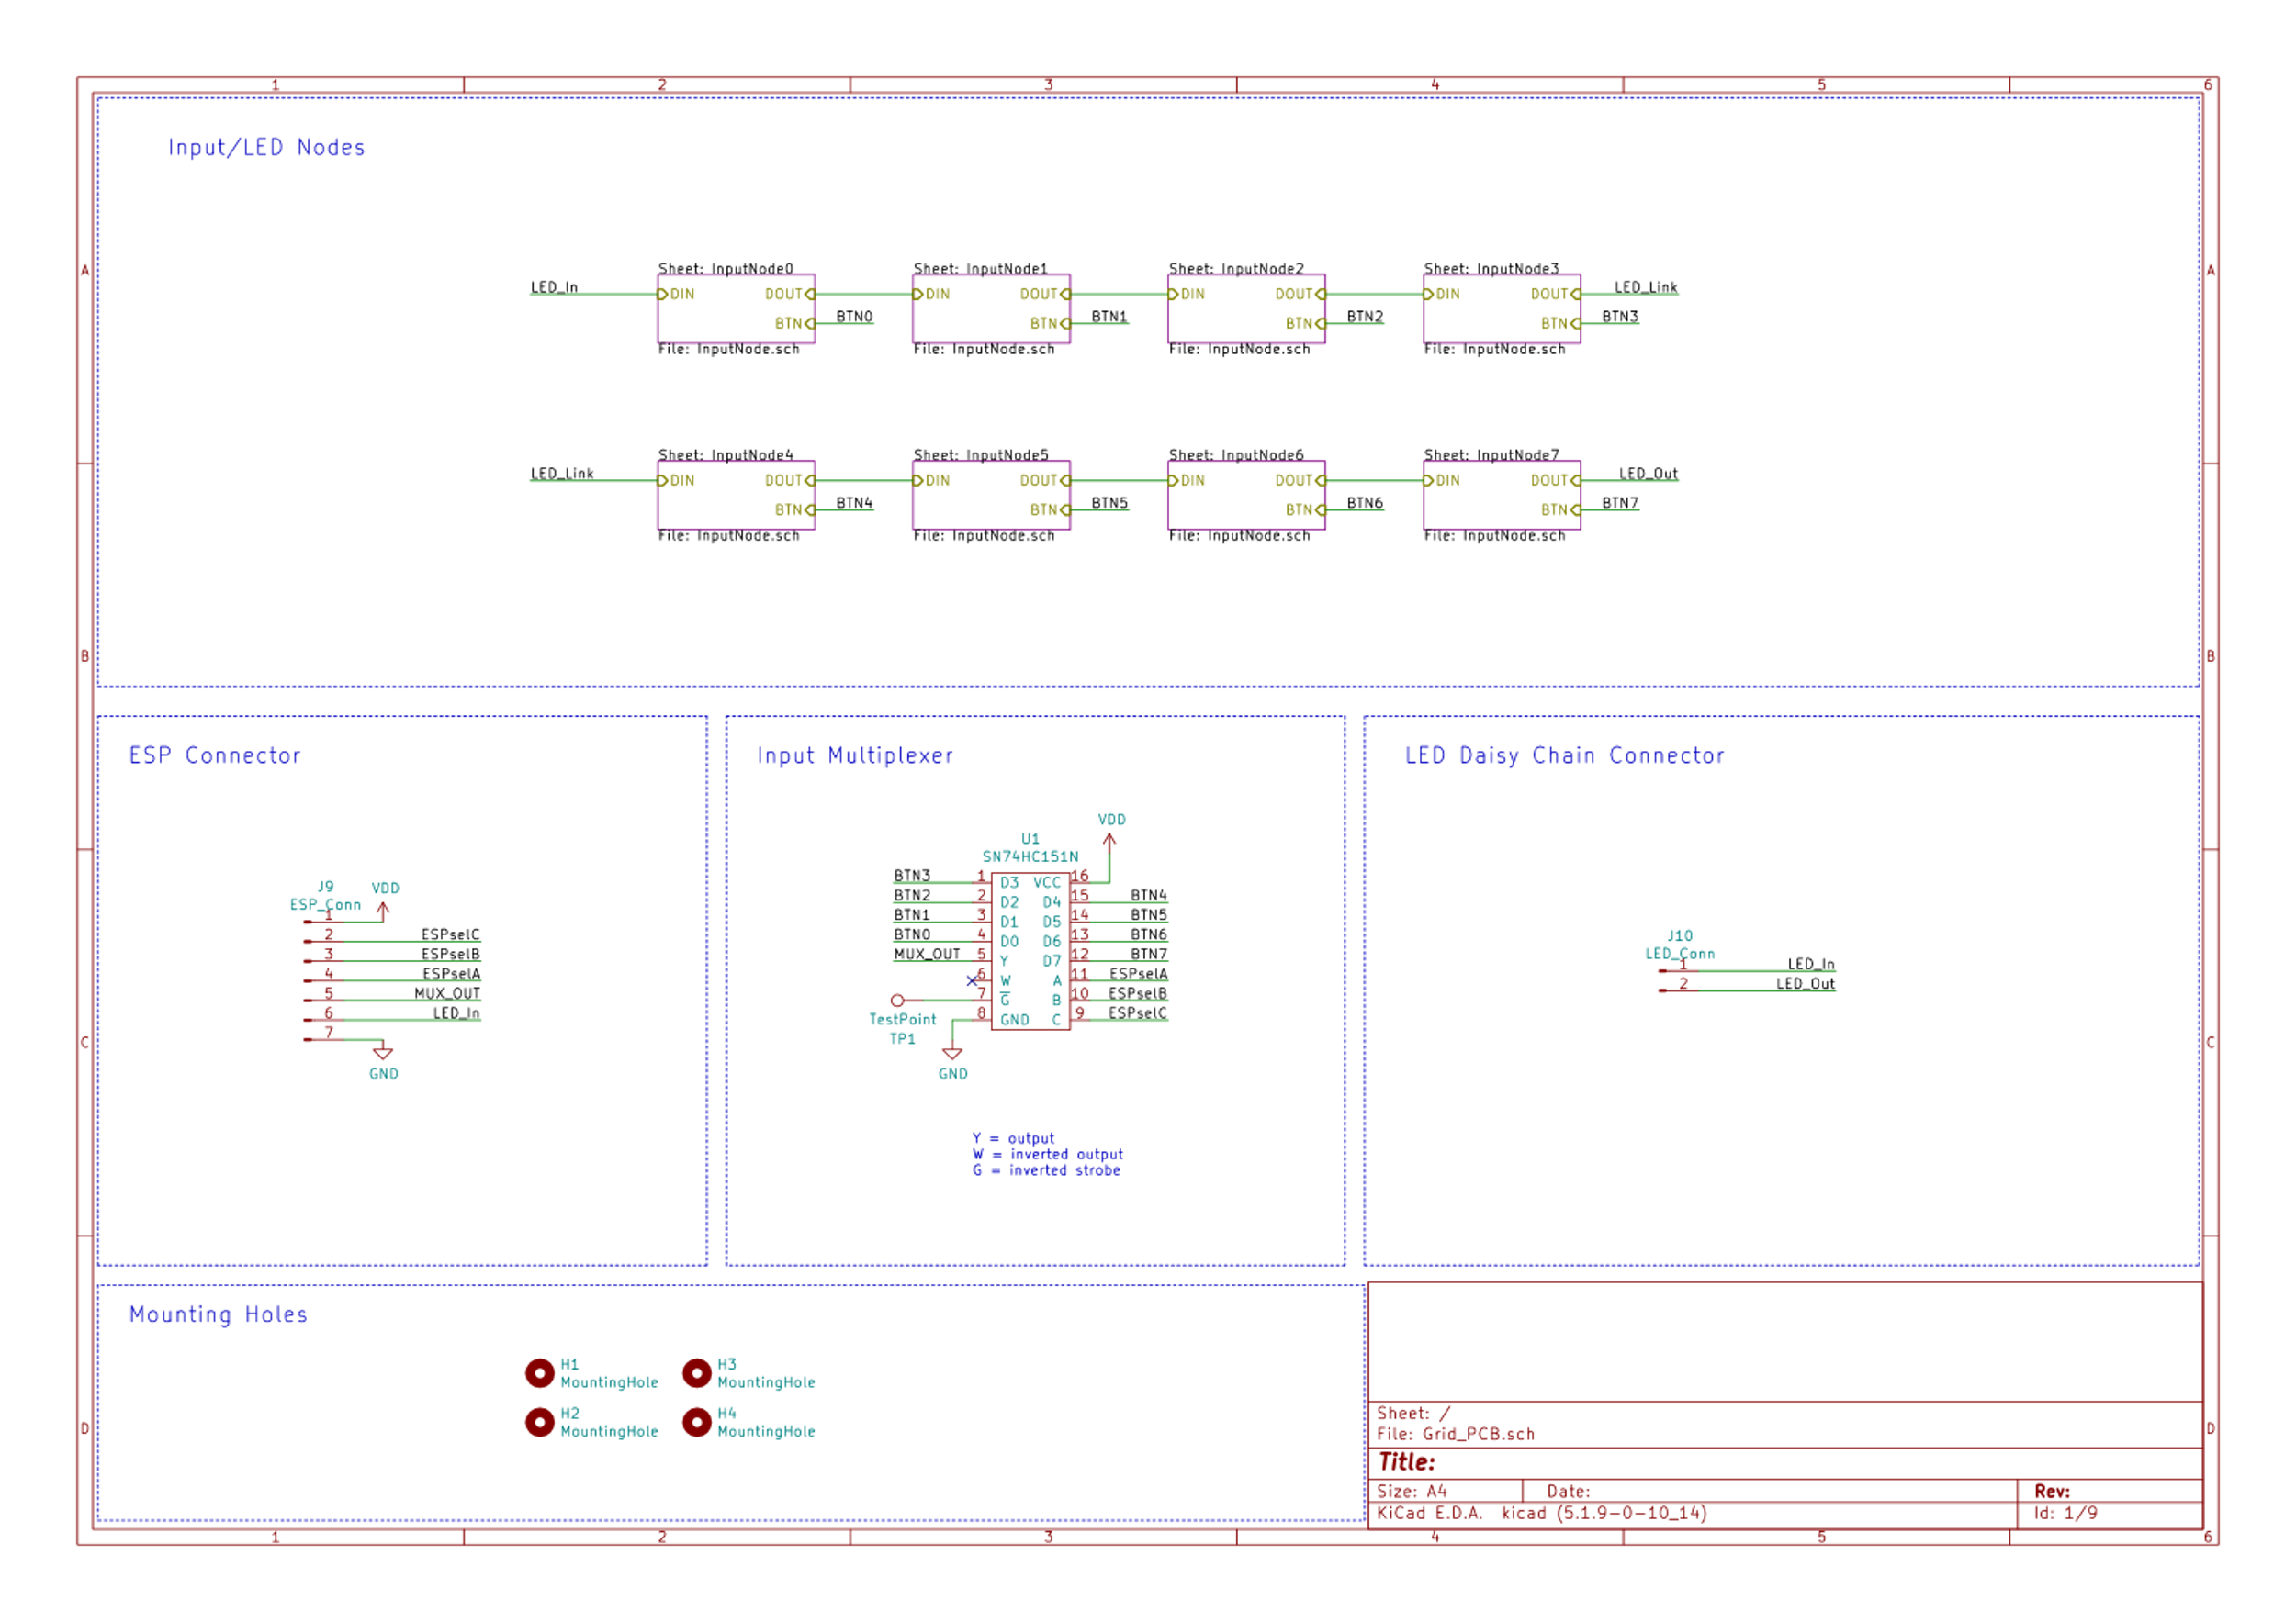

Figure 1: Input/LED Nodes

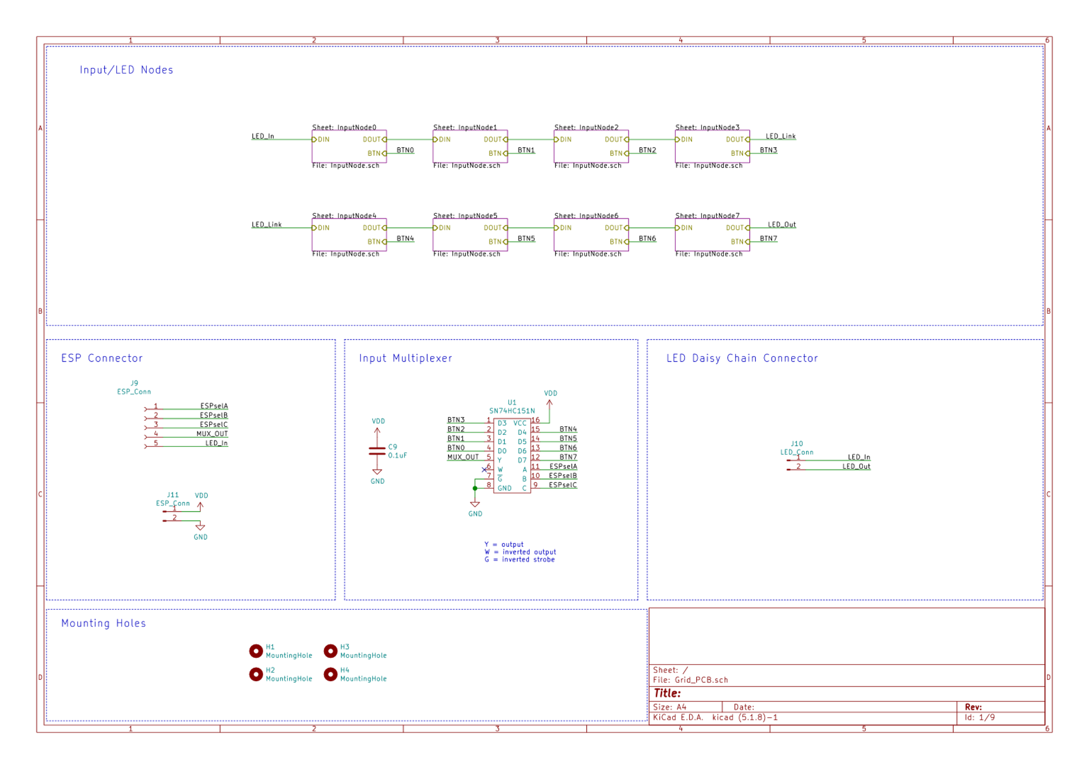

Figure 2: Input Selection MUX

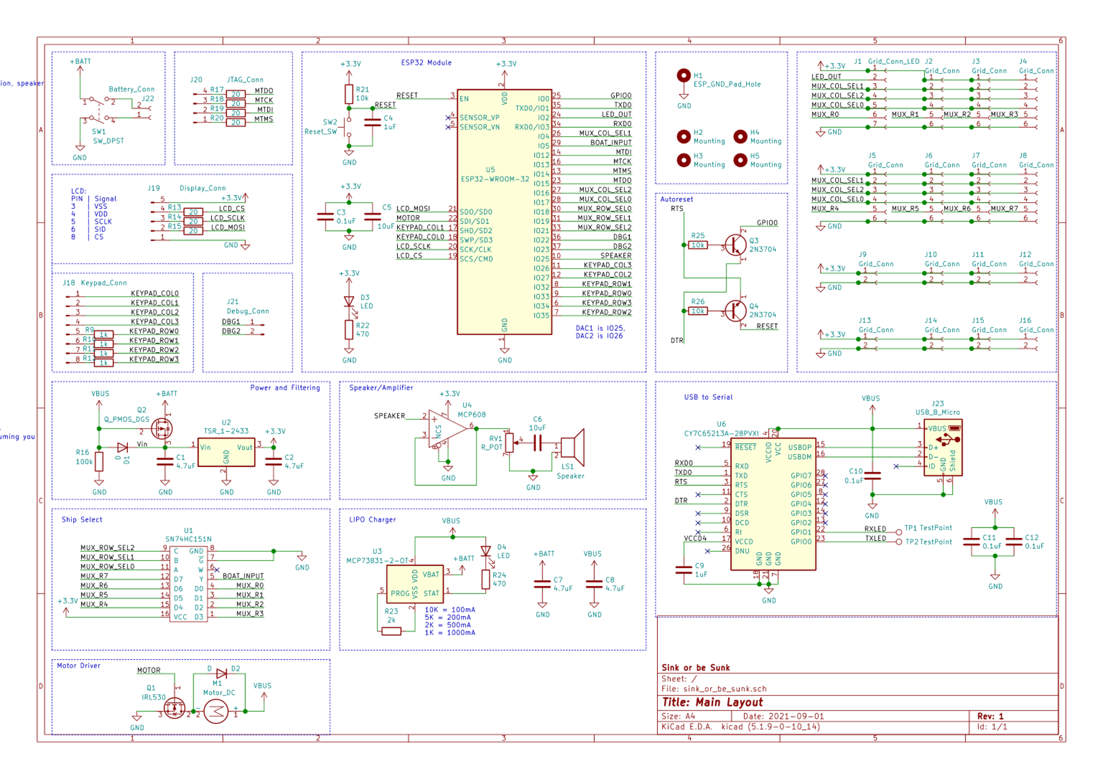

Figure 3: ESP-GRID PCB Interconnects

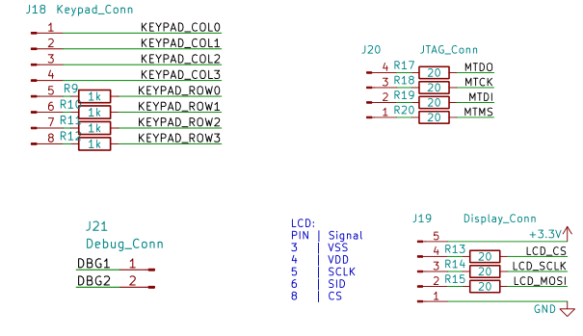

Figure 4: Peripheral Connectors



Figure 5: Battery Isolation Switch



Figure 6: ESP32 Connects



Figure 7: Motor



Figure 8: Speaker

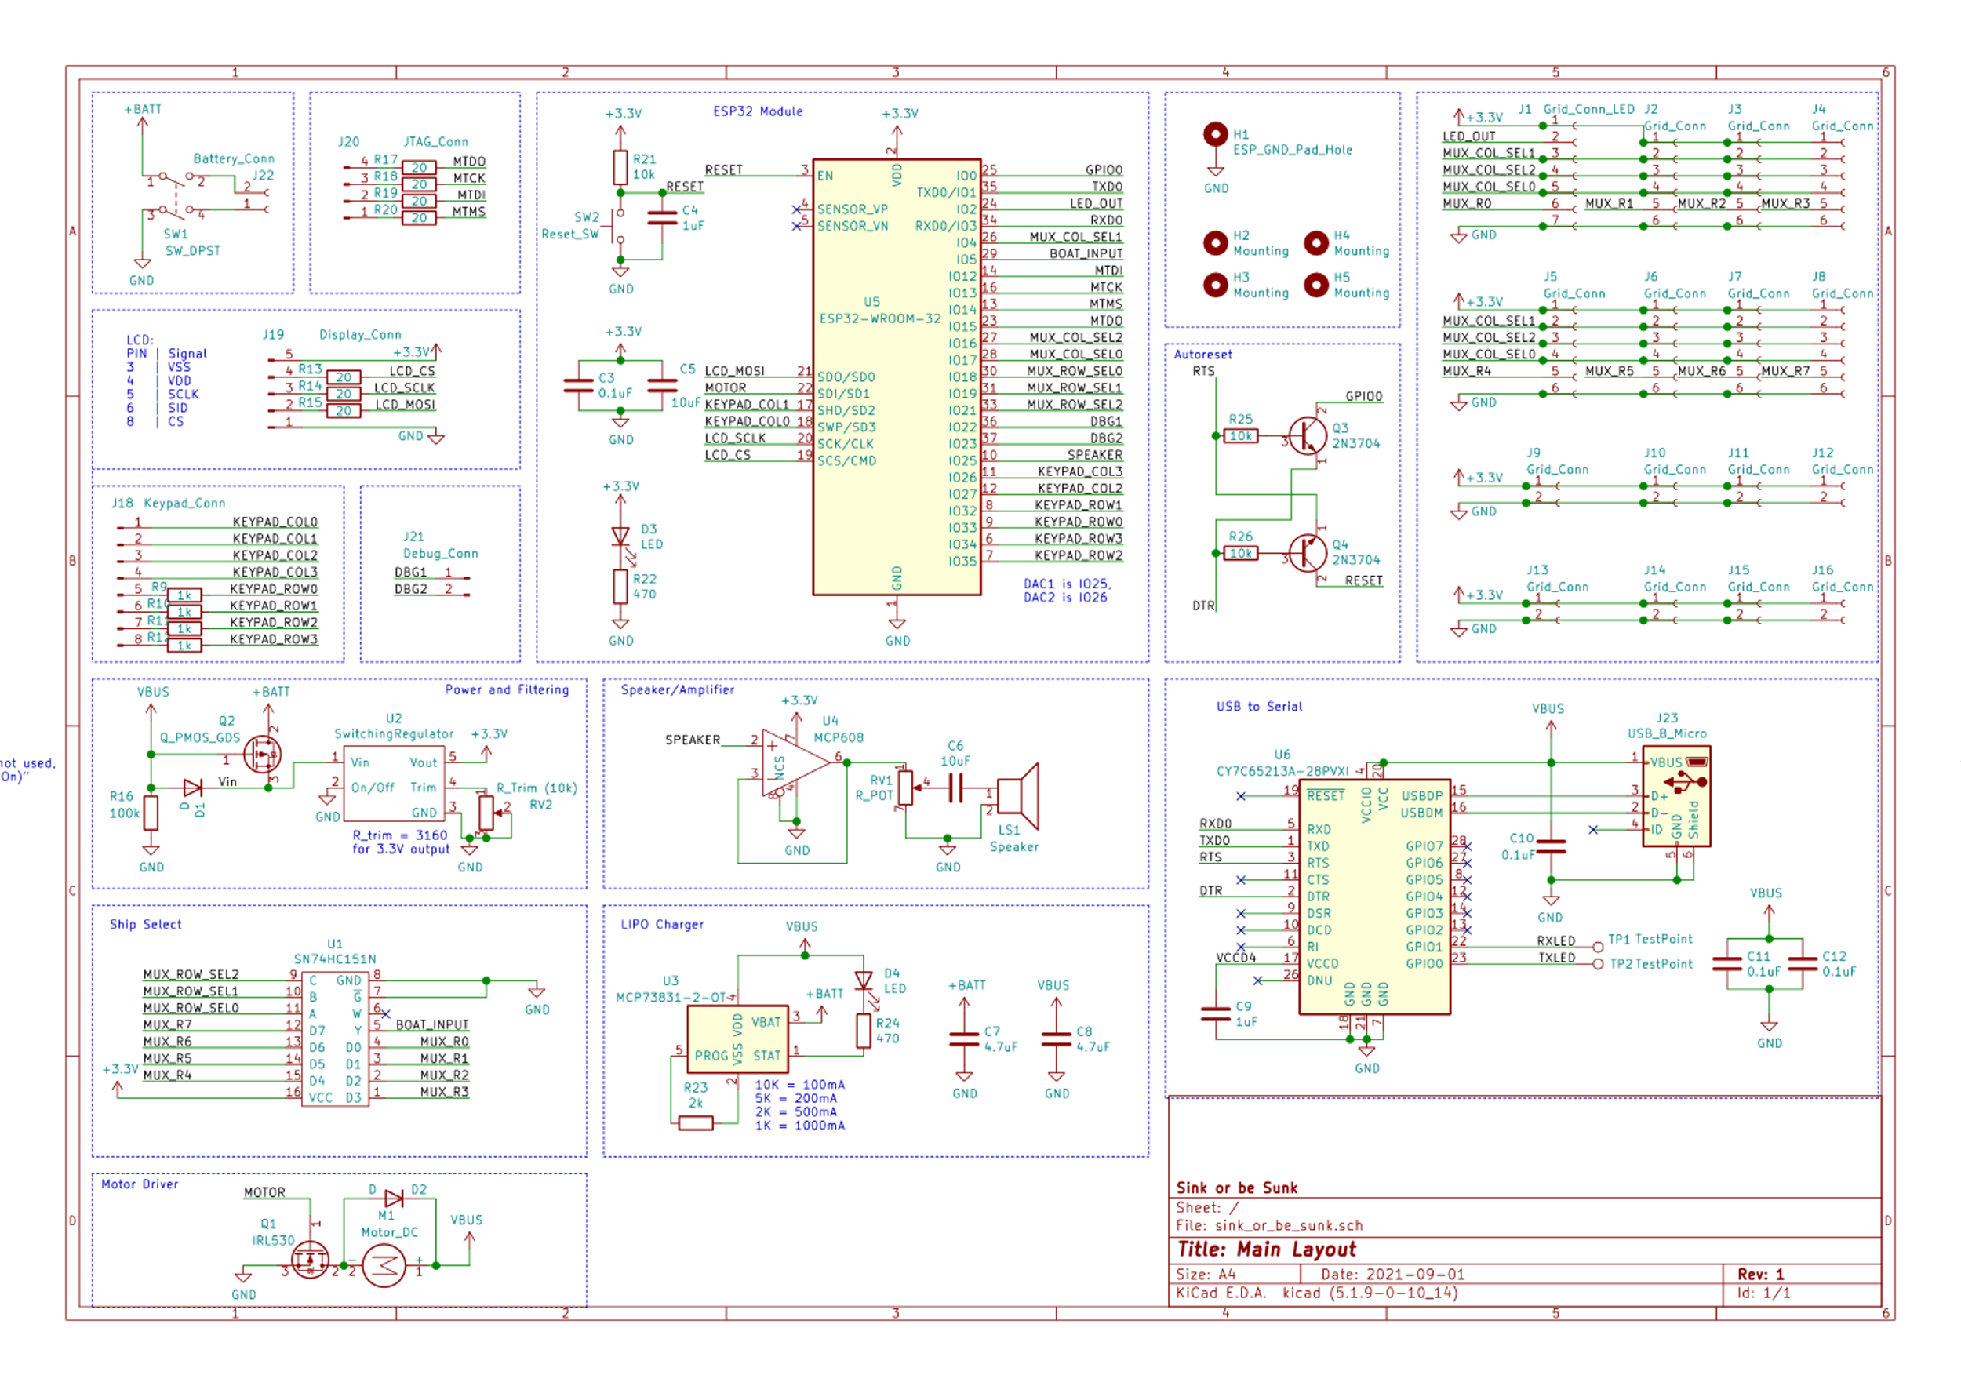

Figure 9: Power Regulation



Figure 10: Battery Charger

Appendix B: FMECA Worksheet

Table 4: Peripheral Circuitry

|  |  |  |  |  |  |  |
| --- | --- | --- | --- | --- | --- | --- |
| **Failure No.** | **Failure Mode** | **Possible Causes** | **Failure Effects** | **Method of Detection** | **Criticality** | **Remarks** |
| 1 | Shorted/burnt out, LED | Voltage Surge from regulator failure, shorted resistor, shorted bypass capacitor | LED does not light up, does not pass bits along to other LEDs resulting in inaccurate lighting | Observation | Low | No damage to other components but needs replacements |
| 2 | Pushbutton on keypad shorted | Mechanical failure | Button would always be read in as pushed down, halting gameplay | Observation | Low | Full replacement of keypad necessary, will not damage other parts of board |
| 3 | Capacitor on speaker circuit blown out | Dielectric capacitor dries out, voltage surge blows out capacitor | Current buffer from OPAMP would be gone, may result in current surge through OPAMP and speaker | Observation | Medium | Current surge would blow out the OPAMP and/or speaker, requiring replacement of multiple parts and the capacitor |
| 4 | Speaker connection broken | Wear and tear from use, current surge from failed capacitor | Audio would not be able to be played | Observation | Low | Replacing speaker should suffice |
| 5 | Boat Detection MUX pins become disconnected | Impacts and environmental damage, current/voltage surge | Boat detection would be unusable, bad data sent back to MC | Observation | Low | Replacing MUX would resolve issue and accurate boat detection would resume |
| 6 | Boat Detection header pins damaged and does not connect short | Wear and tear from user plugging boats in roughly | Boat would not be able to be detected on that pin | Observation | Low | Just need to replace header pins |
| 7 | LCD not displaying | Current surge to fry the screen, damage to SPI connects | LCD will not display gameplay information | Observation | Low | Replace LCD or connectors for SPI communication |
| 8 | Motor MOSFET fails | Current surge, vibration from motor damages MOSFET | Motor left perpetually on or off, may affect 5V systems, Motor out of control may damage board mechanically | Observation | Medium | Motor constantly turned on is biggest issue, as if left unchecked, vibration may damage the board severely |
| 9 | Motor breaks | Current surge, MOSFET damaged | Motor fragments damage mechanical board and/or user, motor no longer works | Observation | High | If the motor fragments, it is high criticality, but merely no longer working is low criticality |
| 10 | Peripheral Connections become disconnected | Mechanical vibrations and impacts | Peripherals do not respond or respond inaccurately | Observation | Low | Replacing connectors would fix issue |

Table 5: Power System

|  |  |  |  |  |  |  |
| --- | --- | --- | --- | --- | --- | --- |
| **Failure No.** | **Failure Mode** | **Possible Causes** | **Failure Effects** | **Method of Detection** | **Criticality** | **Remarks** |
| 11 | Low 3.3 voltage on board | AC power drop, battery power drop, DC/DC converter fails, AC/DC converter fails | Microcontroller and board browns or blacks out, board unresponsive | Observation | Medium | May damage other components that are in use by 3.3 V system |
| 12 | High 3.3 voltage on board | AC power surge, battery power surge, DC/DC converter fails, AC/DC converter fails | Board unresponsive and Microcontroller and peripherals do not power up, may fry some components | Observation | High | May damage some or all 3.3 V systems depending on severity of surge, may overheat AC/DC converter for a fire |
| 13 | Low 5.0 voltage on board | AC power drop, DC/DC converter fails, AC/DC converter fails | Motor and LCD are unresponsive as they do not have sufficient power | Observation | Medium | May damage other components that are in use by 5.0 V system |
| 14 | High 5.0 voltage on board | AC power surge, DC/DC converter fails, AC/DC converter fails | Motor and LCD are either unresponsive or fries components, motor spinning too fast | Observation | High | May damage some or all 5.0 V systems depending on severity of surge, may overheat AC/DC converter for a fire, motor spinning too fast may affect user |
| 15 | AC/DC Converter Failure | AC power fluctuation, external damage, | Board switches to battery power, motor no longer useable | Observation | High | Depending on type of failure, AC/DC wall plug may overheat, but if shuts off quietly there is no issue besides replacement |
| 16 | Battery Charger failure | Battery degradation, IC regulator chip failure | Battery charges incorrectly, with unpredictable results | Observation | High | Incorrectly charging battery may lead to fires and toxic emissions |

Table 6: Microcontroller

|  |  |  |  |  |  |  |
| --- | --- | --- | --- | --- | --- | --- |
| **Failure No.** | **Failure Mode** | **Possible Causes** | **Failure Effects** | **Method of Detection** | **Criticality** | **Remarks** |
| 17 | RF Module failure | EM surge into antenna, power surge into MC, overheating | ESP32 no longer able to contact server | Observation | Medium | Would need to replace entire MC as they are integrated |
| 18 | GPIO Pin failure | Current surge into pin, power surge, peripheral input out of spec | GPIO pin and communication to peripheral has loss of communication | Observation | Low | Entire MC would need to be replaced to restore functionality |
| 19 | DAC failure | Surge of current from failure of OPAMP buffer, capacitor, and speaker | Audio no longer able to be played | Observation | Low | Entire MC would need to be replaced to restore functionality |
| 20 | Reset triggered on Micro | Pull-up resistor for reset is open, decoupling capacitor open, reset switch stuck | Board automatically restarts | Observation | Low | Must hunt for perpetrator of issue |
| 21 | Micro incorrectly or stops performing instructions | Passive resistors broke, transistors damaged, noise on 3.3 V power, software | Board is frozen | Observation | Low | Replace MC |